MACH4METAL

metalworking machinery
Transito 21,
6909 DA BABBERICH, Netherlands
Tel. + 31 (0)316 – 247123
Fax. + 31 (0)316 - 247956

Bank No : 66.52.13.883
IBAN : NL33 INGB 0665 2138 83
BIC : INGBNL2A
info@mach4metal.com www.mach4metal.com www.mach4metal.com

TOS TRENS SN 710 x 4000 mm
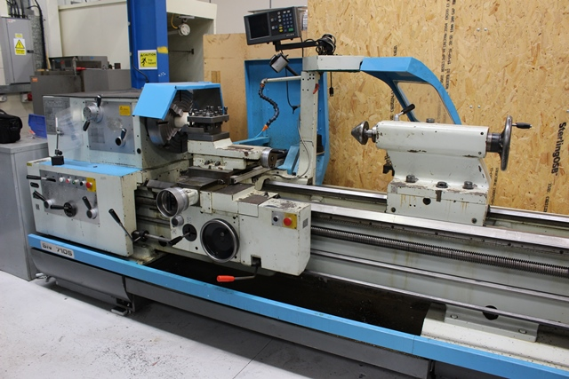

- Make : TOS Trensin
- Typ : SN 710 S
- Age : 2002
- Mach.No. : 72 529

- Max. turning Ø bed : 720
- Max. turning Ø carriage : 430
- Max. turning Ø gap : 960
- Centre distance : 4.000
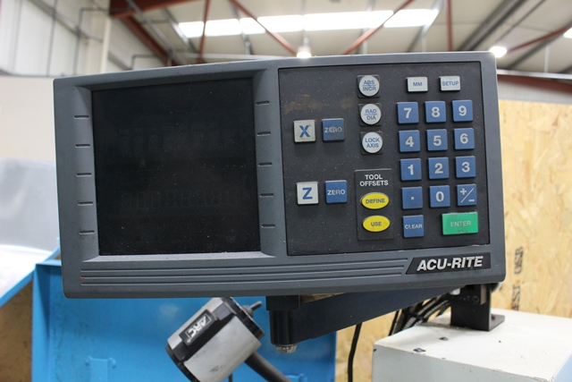
- Bed width : 450

- Spindle bore : 77
- Speeds 18 steps : 1600

- Pinole Ø : 100
- Stroke pinole : 240
- Taper : Mk 6

- Dimensions:
- Length : 6.015
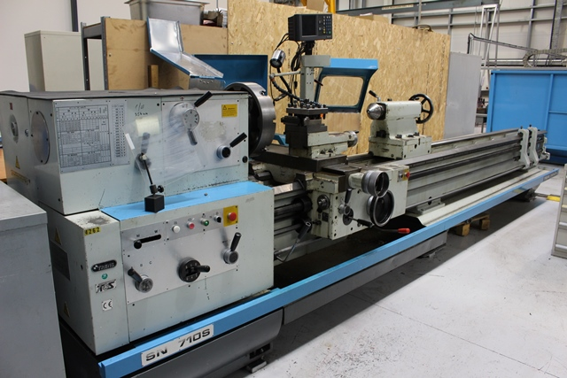
- Width : 1.400
- Height : 1.700
- Weight : 3.890 Kg

- Steady rest
- 3 axis ACCURITE Dro
- CE safety guides / covers
- 4 chuck Ø
- Sandvik Capto C5 tool system
- Power feed on top slide

Please Note: The above information has been obtained to the best of our ability and belief from, and from the manufacturers where possible. It is given in good faith, but its accuracy can not be guaranteed. Accordingly, it will not form a representation or constitute contractual terms. We advise you to check any vital details!

